ORDER MANAGEMENT SYSTEM
Duke Bike E-commerce Database Management System

1. Database Design

1.1 Orders Table
Attribute | Data Type | Key Type / Constraint
Order_ID | NUMBER | Primary Key
Customer_ID | NUMBER | Customer reference
Order_Date | DATE | Order date
Total_Amount | NUMBER(10,2) | Total amount

1.2 Order_Details Table
Attribute | Data Type | Key Type / Constraint
Order_Detail_ID | NUMBER | Primary Key
Order_ID | NUMBER | Foreign Key
Product_ID | NUMBER | Product reference
Quantity | NUMBER | Quantity
Unit_Price | NUMBER(10,2) | Unit price
Subtotal | NUMBER(10,2) | Subtotal

2. Table Relationships
Orders (Order_ID) -> Order_Details (Order_ID). Customer_ID identifies the customer placing the order, and Product_ID identifies the Duke Bike product in each order detail.

3. Order Data Insertion
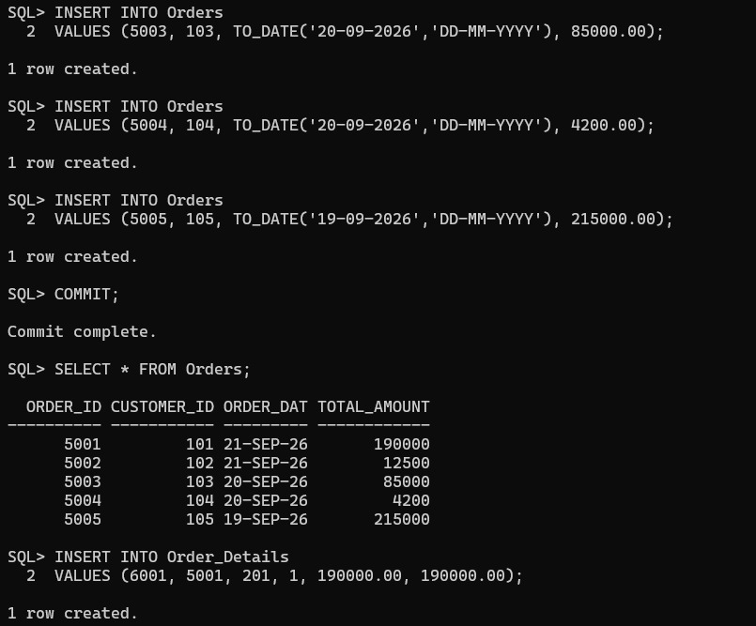

4. Order_Details Data Insertion
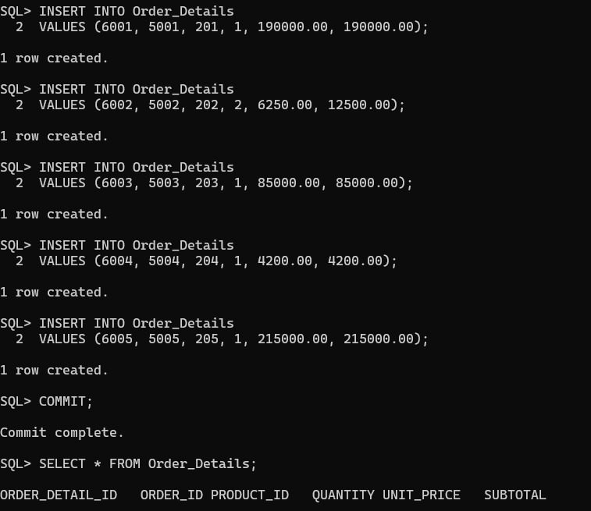

5. Order Modification Operations
